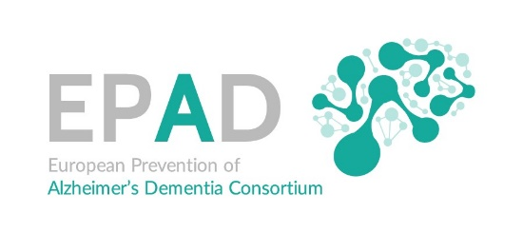
EPAD Deliverable 7.6
Business Plan v1

Executive Summary
The EPAD consortium is an interdisciplinary research initiative that aims to improve the understanding of the early stages of Alzheimer’s disease (AD) and deliver new preventative treatments. The largest ever public-private partnership in AD research, EPAD transcends disciplinary boundaries to combine knowledge and expertise from 39 European partner organisations across multiple sectors. Together, the consortium is developing the EPAD platform on which new therapies can be tested in a streamlined and efficient way, delivering more effective, targeted interventions that can slow or stop dementia.

The two main components of the EPAD model include the Longitudinal Cohort Study (LCS) as the primary foundation, and the Proof of Concept (POC) platform to deliver an adaptive, multiarm proof of concept studies for Intervention Owners (IOs). The EPAD operational structure consists of a Sponsor who takes the lead in regulatory and legal matters and who organizes the administrative activities for the continued operation of the LCS and the POC. The major Sponsor activities include the coordination of the POC Agreement with Intervention Owners and the Master CRO Agreement with the CRO and Intervention Owners, for execution of the POC trials, and the TDC Agreements for the execution of the LCS and POC trials.

EPAD will be funded primarily through a detailed cost model for IOs. Under ongoing analysis are the fixed costs associated with the LCS and infrastructure to sustain the platform. It is anticipated that revenue will be approximately €25 MM for prodromal and €29MM for preclinical interventions to deliver a favourable profit margin, such to be analyzed for the final plan. For additional investment in the EPAD infrastructure, a robust business development effort will be conducted to engage partners who share the EPAD mission.

EPAD will be deemed to be successful if it can sustain both the LCS and POC platform for at least three years post the IMI funding period with at least five Interventions. After that time, the consortium will be able to objectively demonstrate the value proposition of the EPAD model.
For more information: info@epad.org

